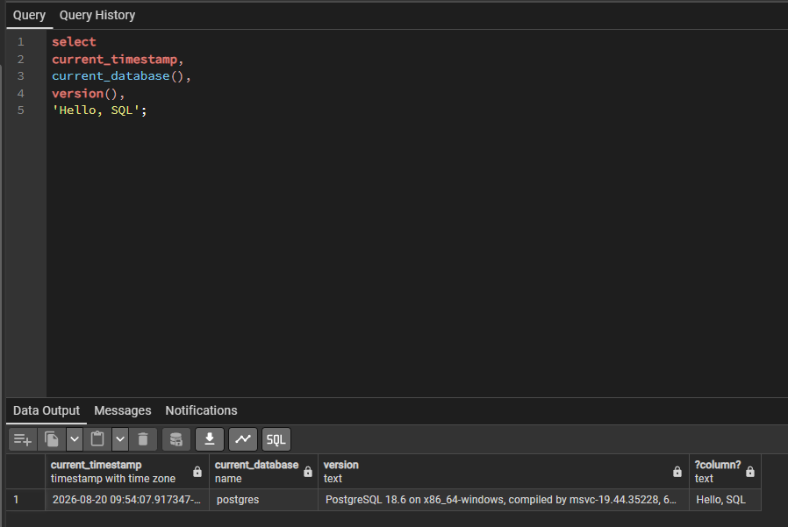
How to create a database in PostgreSQL.
- To create a database, you need just one line of SQL.
- Launch pgAdmin
- Click postgres once to highlight it
- Open the query tool
- Enter the code
- Click execute
How to create a table
- Open the pgAdmin Query Tool
- Copy the Create Table script into the SQL editor
- Execute the script
- Expand tables to view new table
Why semicolons are important in SQL
- They are used for statement separation and execution
At least two examples of data types you might use in a table. Text and integer

